**Aim:​**­ To chose a process model for the project

**Objective​:**

The process models represent a networked sequence of activities, objects, transformations, and

events that embody strategies for accomplishing software evolution. Such models can be used to develop more precise and formalized descriptions of software life cycle activities. Their power

emerges from their utilization of a sufficiently rich notation, syntax, or semantics, often suitable

for computational processing.

The goals of a process model are to be:

● Descriptive

● Prescriptive

● Explanatory

● Track what actually happens during a process

● Take the point of view of an external observer who looks at the way a process has been performed and determines the improvements that must be made to make it perform more effectively or efficiently.

● Define the desired processes and how they should/could/might be

performed.

● Establish rules, guidelines, and behavior patterns which, if followed,

would lead to the desired process performance. They can range from strict

enforcement to flexible guidance.

● Provide explanations about the rationale of processes.

● Explore and evaluate the several possible courses of action based on

rational arguments.

● Establish an explicit link between processes and the requirements that the

model needs to fulfill.

● Pre­defined points at which data can be extracted for reporting purposes.

The activity of modeling a business process usually predicates a need to change processes or

identify issues to be corrected. Process modeling addresses the process aspects of an Enterprise Business Architecture, leading to an all encompassing Enterprise Architecture. The relationships of a business processes in the context of the rest of the enterprise systems, data, organizational structure, strategies, etc. create greater capabilities in analyzing and planning a change. One real world example is in corporate mergers and acquisitions; understanding the processes in both companies in detail, allowing management to identify redundancies resulting in a smoother merger.

Prerequisites:

The knowledge about the process models such as waterfall model,spiral model,incremental model,agile model, RAD model,etc. that are used in industries for developing the products. One

should be aware about when to use each of these models,their strengths and weakness.

**Chosen process model:** ­ Spiral Model

The spiral model combines the idea of iterative development with the systematic, controlled aspects of the waterfall model.Spiral model is a combination of iterative development process model and sequential linear development model i.e. waterfall model with very high emphasis on risk analysis.It allows for iterative releases of the product, or refinement through each iteration around the spiral.

The spiral model has four phases. A software project repeatedly passes through these phases in iterations called Spirals.

* **Identification:**This phase starts with gathering the business requirements in the baseline spiral. In the subsequent spirals as the product matures, identification of system requirements, subsystem requirements and unit requirements are all done in this phase.This also includes understanding the system requirements by continuous communication between the customer and the system analyst. At the end of the spiral the product is deployed in the identified market.
* **Design:**Design phase starts with the conceptual design in the baseline spiral and involves architectural design, logical design of modules, physical product design and final design in the subsequent spirals.
* **Construct or Build:**Construct phase refers to production of the actual software product at every spiral. In the baseline spiral when the product is just thought of and the design is being developed a POC (Proof of Concept) is developed in this phase to get customer feedback.Then in the subsequent spirals with higher clarity on requirements and design details a working model of the software called build is produced with a version number. These builds are sent to customer for feedback.
* **Evaluation and Risk Analysis:**Risk Analysis includes identifying, estimating, and monitoring technical feasibility and management risks, such as schedule slippage and cost overrun. After testing the build, at the end of first iteration, the customer evaluates the software and provides feedback.

Advantages of spiral model:

1. Changing requirements can be accommodated and accurately.
2. Development can be divided into smaller parts and more risky parts can be developed earlier which helps better risk management. Hence, extensive use of prototypes.

Disadvantages of spiral model:

1. Management and process is more complex.End of project is indefinite because of large number of intermediate stages requires excessive documentation.
2. Not suitable for small or low risk projects and could be expensive for small projects.

**Justification:**

1. The different functionalities that are to be provided to the users have a wide scope of expansion keeping in mind the scalability and broad domain of the project.Hence, the spiral model will provide us the freedom to add or remove functionalities from the system.
2. There are total three types of clients involved in the system, which are the sponsors, customers and organizers. Hence to design an all round database and system design we need an iterative approach to build the system over multiple prototypes.
3. The idea of the whole project revolves around people’s expectations about events in the city, which continuously change according to the trends. Any new product line should be released in phases to get enough customer feedback. Significant changes are expected in the product during the development cycle.
4. The scope of the project includes events of all budgets and scales. Moreover, there are chances of events losing public support and getting cancelled. Hence, a robust risk management plan is of utmost importance. This is supported by spiral approach.

**Diagram:**

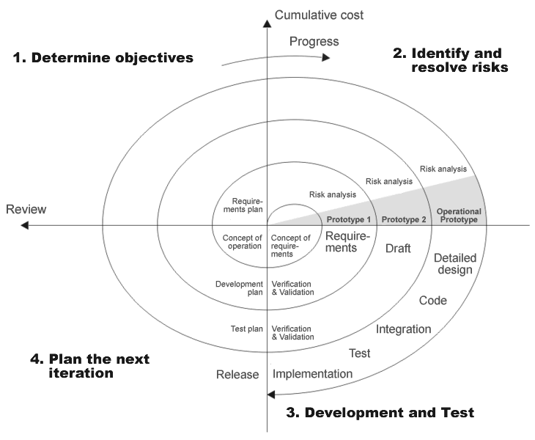

Functions which will be delivered at the end of each Spiral:

**Spiral 1:**

1. Basic user login interface. People will be able to make accounts and select which event they have to attend.
2. Event creation interface. It will involve primary types of event tags like music,sports,education etc.
3. Event support and backing options where you can buy tickets and fund events.

**Spiral 2:**

1. Increased security options for the account like two step login and OTP.
2. Official accounts for sponsoring brands. They can directly sponsor via their official account on the website
3. Mailing System.
4. Online payment options and add credit card option.
5. Rating events and feedback system.

**Spiral 3:**

1. Perks system introduction. People get benefits for all the events they attend. Level of different perks and added benefits will be defined.
2. Recommendation system. Based on your past attended events the system will recommend you the events to be attended.
3. Discussion Forum­. A discussion forum is provided where users can discuss among themselves about what they expect from an event.

**Explanation of each phase and deliverables of each phase** .

**Phase 1**: **Requirement Gathering and defining objectives of project:**

Before developing an iteration of the project it is essential to identify the following aspects:

1. The requirements of the end user.
2. The financial, scheduling and functional requirements.

Hence in this phase, requirements are gathered from the end user through various activities like questionnaires, personal interviews, brainstorming sessions and group interviews. The deliverables at the end of this stage is the ​Defining the scope of the project, Project plan report and Providing a reference to the designers about the complexity of the design depending upon the budget.Depending upon the no. of iteration the work involved in phase 1 changes. For example, first iteration will involve a lot of basic brainstorming while further iterations will be more inclined to defining objective of iteration depending upon deadlines and budget.

**Phase 2**: **Identifying and resolving risks:**

Estimating the schedule and the cost that would be incurred, time available at hand and accordingly deciding the feasibility of the product is done. System Design helps in specifying hardware and system requirements and also helps in defining overall system architecture. The deliverable at the end of this stage is the Design specification document,an updated project plan report, Cost estimation and analysis report, Risk estimation and analysis report, Project timeline and Detailed estimate of project duration​.

**Phase 3: Developing and testing the product**

This stage unlike phase 1 and 2 involves technical development of the product based on the earlier outcomes. With inputs from system design, the system is first developed in small modules, which are integrated in the next phase. The deliverable at the end of stage is the unit test cases and results. The deliverable of this phase is a Fully functional set of software that satisfies the requirements, Project Assessment, Project Metrics of this particular iteration.

Hence, outcome of this phase is a dilute or updated version of the project based on the goals set in the first two iterations. The outcome is tested on all possible test cases and only then finalized. During each iteration, the course of development of this product changes according to the risk plan and the identified modifications.

**Phase 4: Closure and review of the whole iteration:**

At the end of development phase, a complete analysis is made. There is a comparison between the defined scope and developed product. We recognize which objectives are fulfilled and which are not. Depending upon the outcomes of this phase reference reports for the first phase of the next iteration are made. We plan a head start for the next iteration and try to guess what are the modifications to be done to the current development plan depending upon the budget, project delivery date, customer feedbacks, risk management plan and other unforeseen circumstances.

**Conclusion:**

Thus, we understood the concept of process model and succeeded in identifying the appropriate process model which is spiral model. Spiral model is easy to understand and use and its main advantage is modifying the system is easy against changing circumstances and provides flexible risk management.